Mounted disc harrow BND-1,7M
Mounted disc harrow BND-1.7M is designed for cutting layers of soil after plowing land, for seedbed preparation, after harvesting root crops.
Harrow is attached with tractors of class "Belarus-320" MTZ-80/82, T-40M and T-40AM and other tractors of 0.6 ... 1.4 ton unit-equipped with hydraulic system. When it’s attached with tractors of class 0.6, it’s possible to install on the tractor front-loads of 100 kg

Technical characteristics
Harrow’s type | mounted
Productivity in 1 hour time, ha / h, not less than | 1,36
Working width, m, not less than | 1,7
Working speed, km / h | 8-10
Transportation speed, km / h | до 20
Processing depth, cm | 8-12
Disc diameter, mm | 460
Attack angle of batteries, degrees | 9, 12,15,18, 21
The distance between disks, mm | 230
The quantity of discs:
carved х | 15
solid х | 1
Mashine’s dimensions, mm (attack angle is 18 °):
Length | 1980±30
Width | 1770±30
Height | 1045±20
Weight, kg | 500

Mounted disc harrow BND-2
Harrow is designed for cutting blocks after plowing and surface treatment of the compacted soil after harvesting cultivated crops. Harrow is attached tractors with MTZ-80/82.

Technical characteristics
Harrow’s type | mounted
Productivity in 1 hour time, ha / h, not less than | 2,1-2,8
Working width, m, not less than | 2,2
Processing depth, cm
after plowing | till 20
Bearing | ball, radial, single row
Transportation speed, km / h | 20
Working speed, km / h | 8-12
Ground clearance mm, not less | 300
Attack angle of batteries, degrees | 8,12,16,24
Weight, kg | 1000
Disc diameter, mm | 650
Attendants, pers. | tractor-driver

Mounted disc harrow BND-3
Harrow is designed for cutting blocks after plowing and surface treatment of the compacted soil after harvesting cultivated crops.

Technical characteristics
Harrow’s type | mounted
Attached to | tractor МТZ-82
Productivity in 1 hour time, ha / h, not less than | 3
Working width, m, not less than | 3,2
Processing depth, cm
single pass | 8-12
after plowing | till 20
Transportation speed, km / h | 20
Working speed, km / h | 8-12
Ground clearance mm, not less | 300
Attack angle of batteries, degrees | 8,12,16,24
Overall dimensions in transport position, mm, not more:
length | 3180 (3780)
width | 3490
height | 1450
Weight, kg, not more | 1470
Disc diameter, mm | 650

Mounted disc heavy harrow BNT-2
The harrow is designed for loosening land, that is silted with woody debris thickness of 2 cm and small stones not larger than 10 cm. Harrow is attached with tractors Class 2 ton. (MTZ-1221, 1523, T-150), equipped with a separate unit system. Guarantee is 12 MONTHS!
Technical characteristics
Harrow’s type | mounted
Attached to | МТZ-1221 and other tractors of class 2
Productivity in 1 hour time, ha / h, not less than | 1,9
Working width, m, not less than | 2,15
Transportation speed, km / h | 20
Processing depth, (for 2-3 steps), cm | till 18
Working speed, km / h | 8-10
Ground clearance mm, not less | 300
Overall dimensions in transport position, mm, not more:
length | 2410
width | 2465
height | 1400
Disc diameter, (metal sheet 14 st.65G), mm | 650
Weight, kg, not more | 1420

Disc mounted meliorative harrow BDN -3,0М
Designed for loosening cleared from forests-bushes meliorative land to the depth of 0.3 m with a turnover of formation at 110-130 degrees. The land can be silted with woody debris with thickness up to 0.1 m in the amount of to 5 m³ / ha and small stones up to 0.2 m in volume of 25 m³/ha.
The harrow is attached with tractor К-701. Working bodies are spherical cut-harrow discs, which are collected in six sections 2 pcs. each. Depth of tillage is adjusted by changing the angle of disk sections' attack and trunnions’ installation in four positions in height with locking fingers.
Technical characteristics
Harrow’s type | mounted
Attached to | tractor К-701
Productivity at the speed of 7.1 km / h, m / h | 1,5
Working width, m, not less than | 2,9
Working speed, km / h | 4,2-10,3
Transportation speed, km / h | 15
Processing depth, mm | 150-300
Quantity of disk sections | 6
Disc diameter, mm | 1000, 10
The distance between the discs, mm | 520, 20
Angles of the front section’s attack, degrees | 20, 25
Angles of the front section’s attack, degrees | 25, 30
Overall dimensions without tractor, mm:
length | 4200
width | 3300
weight, kg | 3200

Trailed disc harrow DS-40

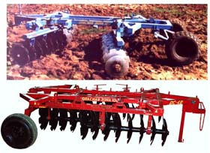
Harrow is intended for cultivation and tilling, weeding, grinding crop residues. It’s also used for cutting layers of soil after plowing of virgin land, for seedbed preparation without preliminary plowing, tillage after harvest of row crops, care of meadows and pastures, as well as for cutting layers of land.

Technical characteristics
Harrow’s type | semi-mounted
Quantity of discs, pcs. | 33
Productivity in 1 hour time, ha / h, not less than | 3,5
Working width, m, not less than | 4,0
Processing depth, cm
for 1 step | 8-10
after plowing | till 20
Transportation speed, km / h | 20
Working speed, km / h | 8-12
Ground clearance mm, not less | 250
Angles of batteries’ attack, degrees | 9,12,15,18
Overall dimensions in transport position, mm, not more:
length | 5370
width | 2400
height | 1450
Weight, kg, not more | 2400

Trailed disc harrow BPD-3М
Harrow BPD-3M is used for cutting layers of soil after plowing land for seedbed preparation without preliminary plowing, for processing after harvesting root crops, care of meadows and pastures, that are clogged with small stones, not larger than 10 cm thick and woody debris till 2 cm . Harrow is attached with tractors MTZ-1221, T-150, T-150K, DT-75S and other tractors of class 3, that are equipped with a hydraulic system.

Technical characteristics
Harrow’s type | trailed hydroficated
Productivity in 1 hour time, ha / h, not less than | till 2,6
Working width, m | 3
Working speed, km / h | 9-12
Disks’ type | spherical cut-out, 2 solid
Disk diameter | 650/510 or 600/460
Quantity of discs | 23, 2 solid
Maximum depth of treatment for 2-3 steps, cm | till 20
Transportation speed, km / h | till 20
Angles of batteries’ attack, degrees | 12,15,18
Raising and lowering of working bodies | with hydraulic cylinders
Габаритные размеры, мм:
Dimensions in the operating position (without tractor)
Length | 4440
Width | 3260
Height | 1180
Weight, kg | 1800

Trailed disc harrow BPD-5МW
This harrow is used for cutting layers of soil after plowing land, for seedbed preparation without preliminary plowing, for tillage after harvesting root crops, care of meadows and pastures, that are clogged with small stones, not larger than 10 cm and woody debris till 2 cm. Harrow is attached with tractors T-150, T-150K, and others of Class 3, that are equipped with unit-hydraulic system.

Technical characteristics
Harrow’s type | trailed hydroficated
Productivity in 1 hour time, ha / h | 4,3
Working width, m | 5
Working speed, km / h | 9-12
Disks’ type | spherical cut-out, 2 solid
Disk diameter | 650/510 or 600/460
The distance between discs, mm | 260 и 210
Quantity of discs, pcs. | 39 and 2 solid
Maximum depth of treatment for 2-3 steps, cm | till 20
Transportation speed, km / h | до 20
Ground clearance mm, not less | 250
Track Width, mm | 2000
The number of disc batteries | 8
Angles of batteries’ attack, degrees | 12,15,18
Raising and lowering of working bodies | with hydraulic cylinders
Characteristics of the undercarriage:
wheels’ type | pneumatic
quantity | 2
tire size, inch | 13,0 / 75 - 16
tire pressure, MPa | 0,2-0,3
Overall dimensions mm, not more than (at the angle of attack of 18):
in the working position (without the tractor)
length | 4000+100
width | 5250+100
height | 1370+100

Trailed disc harrow BPD-7МW
Harrow BPD-7MW is designed for loosening and tilling, weeding, grinding residue. It is used for cutting layers of soil after plowing of virgin land for seedbed preparation without first plowing, for tillage after harvest row crops, care of meadows and pastures, as well as for cutting layers of land, that is raised with shrub bog plows.

Technical characteristics
Harrow’s type | semi-mounted hydroficated
Productivity in 1 hour time, ha / h
with tractor K-700 on V transmission | 7,61
with tractor K-701 on VII transmission | 7,25
with tractor T-150 on II transmission | 6,03
Working width, m | 7
Maximum depth of treatment for 2-3 steps, cm | 20
Quantity of disc sections | 8
Angles of the front section’s attack, hail. | 12,15,18

Sweeper MP-2.5M for tractor MTZ-80/82
Tow equipment to the tractor MTZ-80/82 for the maintenance of roads and areas is intended for the mechanization of harvesting in urban housing and communal services, for cleaning of roads, squares and other areas of the fallen leaves, dust, urban refuse. At the same time polluting items accumulate in the hopper and eject the assembled body of the car or trailer. The presence of three brushes, vertical and two horizontal, allows for cleaning debris on the roadway, limited with a border. The machine is equipped with a humidification system to prevent dust formation.

Technical characteristics
Equipment’s type | trailed
Attached to | tractor МТZ-80/82
Brush’s drive | hydraulic
Working width, m | 2,5
Hopper capacity for garbage, m3, not less | 2,0
Capacitance of the water tank, m3, at least | 1,0
Ground clearance mm, not less | 250
Working speed, km / h | 20
Transportation speed, km / h | 30
Overall dimensions of equipment mm, not more:
length | 5000
width | 2500
height | 2200
Unloading height, mm | 4100
Working liquid | МГЕ-46В

Attached equipment for cleaning roads and areas, type

UM.T-320
Attached equipment for the maintenance of roads and areas, type UM.T-320 is designed for mechanized cleaning of streets, roads, squares, including fresh snow.

Technical characteristics
Equipment’s type | mounted
Attached to | tractor Belarus-320
Ground clearance mm, not less | 250
The length of the moldboard, mm | 2000 ±20
The length of the brush, mm | 1500±20
Weight of attachments with roller supports (supporting wheels), kg | 490
Working speed, km / h | 10
Transportation speed, km / h | 20
The angles of the moldboard in the plan, degrees | 60, 90
The angles of the brush in the plan, degrees | 60
Overall dimensions of the tractor with equipment mm, not more:
length | 5700
width | 1800

Raising and lowering of working bodies | with hydraulic cylinders

Attached equipment for cleaning roads and areas, type

UM.T-422.1
Attached equipment for the maintenance of roads and areas, type UMT-422.1 for tractor "Belarus-422.1" is designed for mechanized cleaning of streets, roads, squares, including fresh snow.
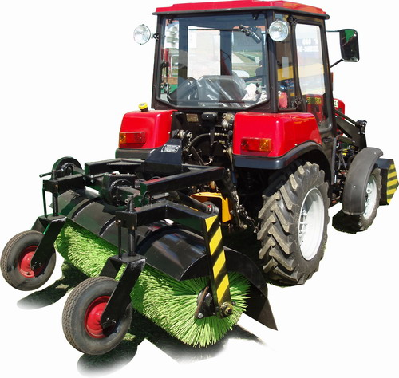
Technical characteristics
Equipment’s type - mounted
Attached to tractor “Belarus”- 422.1
Ground clearance mm, not less - 311±15
length of moldboard, mm - 1730
length of brush, mm - 1700
Weight
with support wheels, kg, not more than - 470±15
Working speed, km / h, not more than - 10
Transportation speed, km / h, mot more than - 25
The angles of the moldboard in the plan, degrees - 60, 90
The angles of the brush in the plan, degrees - 60

Loading equipment FP - 0,25,

FP - 0,25.1 for tractor “Belarus-320”, “Belarus-422.1”
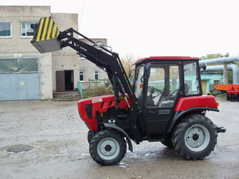
Loading equipment FP-0.25 for tractor Belarus-320 and Belarus-422.1 is designed for loading into vehicles loose materials on the agricultural, constructing, industrial enterprises and farms.
Technical characteristics
Equipment’s type - mounted
carrying capacity, kg: 300
bucket capacity,m³: 0,25
Bucket width, m: 1,2
Ground clearance mm, not less: 300
Transportation speed, km / h, mot more than: 20
Overall dimensions of tractor with equipment, mm, not more:
length 4300
width 1500
Dumping height, mm: 2300
Drive lifting and lowering of the boom and bucket’s actuator rotation are hydraulic from the tractor hydraulics
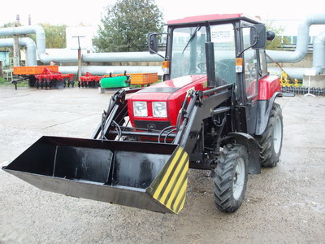

Loading equipment FP - 0,75 for tractor МТZ – 82
Loading equipment FP-0.75 for tractor MTZ-82 is designed for loading into vehicles loose materials on the agricultural, constructing, industrial enterprises and farms.

Technical characteristics

Equipment type | mounted
carrying capacity, kg | 750
Tear-off force, kgf | 1500
bucket capacity,m³ | 0,4
Bucket width, m | 1,5
Ground clearance mm, not less | 250
Transportation speed, km / h, not more than | 20
Overall dimensions of tractor with equipment, mm, not less
length | 5450
width | 1970
Dumping height, m | 2,65
Drive lifting and lowering of the boom and bucket’s actuator rotation are hydraulic from the tractor hydraulics

Attached equipment for cleaning roads and areas, type

UM.T-80
Attached equipment for the maintenance of roads and areas, type UMT-80 is designed for mechanized cleaning of streets, roads, squares, including fresh snow.

Technical characteristics
Attached to | tractor МТZ-80/82
Brush’s drive | mechanical from the tractor’s shaft
Ground clearance mm, not less | 260
length of moldboard, mm | 2500 ±20
length of brush, mm | 1800±20
Weight with a tractor, kg | 4200
Working speed, km / h, not more than | 10
Transportation speed, km / h, not more than | 20
The angles of the moldboard in the plan, degrees | 60
The angles of the brush in the plan, degrees | 30
Overall dimensions of tractor with equipment, mm, not more:
length | 6200
width | 2500

Attached equipment for cleaning roads and areas, type

UM.T-25
Attached equipment for the maintenance of roads and areas, type UMT-25 is designed for mechanized cleaning of streets, roads, squares, including fresh snow.

Technical characteristics

Equipment type | mounted
Basic tractor | Т25/30
Working speed, km / h, not more than | 10-20
Turning radius of the moldboard in the plan, mm | 6000
length of moldboard, mm | 2000
length of brush, mm | 1500
The angles of the moldboard in the plan, degrees | 60,90
The angles of the brush in the plan, degrees | 60,90
Ground clearance mm, not less | 260
Raising and lowering of working bodies | with hydraulic cylinders
Overall dimensions of tractor with equipment, mm:
length | 2000
width | 6200
Weight | 820

Semitrailer tipper PSM-2.5
It’s used in construction, municipal and agricultural organizations for the goods transporting by road and on the field.

Technical characteristics

Maximum carrying capacity, kg | 2500
Platform capacity, m³ | 2.5
Weight of full semitrailer, kg | 800
Full weight, kg | 3300
Overall dimensions of semitrailer, mm
length with the drawbar trailers | 3820
width | 1960
height | 500
Loading height on the floor of the platform, mm | 900
Semitrailer’s base | 2950
track of wheels | 1500
Ground clearance mm, not less | 300
Tires | 100/75-15,3
unloading | tripartite
Angle of platform’s tilting, degrees
on the side | 52
back | 50

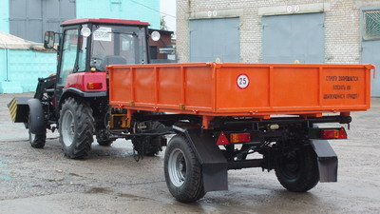

Semitrailer tipper PU-3,0-01
It’s used in construction, municipal and agricultural organizations for the goods transporting by road and on the field.

Technical characteristics

Maximum carrying capacity, kg | 3000
Platform capacity, m³ | 3,0
Weight of full semitrailer, kg | 800
Full weight, kg | 4000
Overall dimensions of semitrailer, mm
length with the drawbar trailers | 3950
width | 1960
height | 550
Loading height on the floor of the platform, mm | 900
Semitrailer’s base | 2950
track of wheels | 1500
Ground clearance mm, not less | 300
Tires | 100/75-15,3
unloading | tripartite
Angle of platform’s tilting back, degrees | 50

Watering semitrailer PU-3.0-02
PU-3.0-01 is used in municipal services, for watering roads, sidewalks, yards, green areas.

Technical characteristics

Base tractor | Belarus-320
Width, m :
washing | 3
watering | 10
Average water consumption, l/m:
during washing | 0,6
during watering | 0,2-0,3
Overall dimensions, mm:
length with the drawbar trailers | 7230
width | 2130
height | 2150
Weight of full semitrailer, kg | 1100
Full weight, kg | 4100
Working speed, km / h:
during washing | 5-10
during watering | 10

Planner meliorative PLM-4,6 (PLM-2,8)
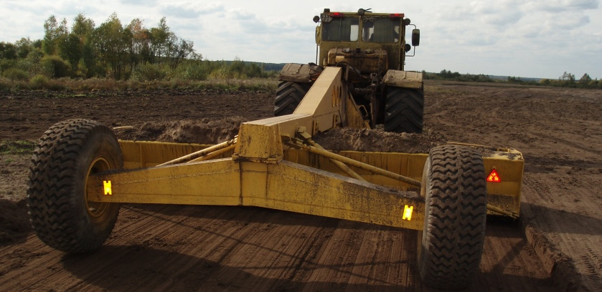
Planner PLM-4.6 is designed to align the drained. The planned area must be cleared of stones with a diameter greater than 200 mm, stumps, also should be plowed. The planner provides alignment roughnesses that are not more than 20 m. And a height (depth) of which is not more than 0.2 m. The ambient temperature under operating conditions can be from -5 to + 50 ° C.

Technical characteristics

Planner type semi-trailed
Base machine tractor К-700, МТЗ -3022
Working width 4,6±0,08
bucket capacity,m³ 3,5
The base in the operative position, m 6,67±0,08
Overall dimensions in operative position,
mm, not more
length 7900
width 4750
height 2100
Working speeds, km/h 5,2 до 6,9
Transportation speed, km/h till 25
Minimum turning radius with
a tractor, m 7,8
Technical productivity ha / h 2,55±0,3
Rut,m 2,9±0,08
Weight, kg 2800±50

